**Distance and Directions with Google Maps**

User Manual

**Slippery Rock University**

Greg Bayne

Kari Franklin

Michael Booser

This manual is for once you’ve successfully launched it. For instructions on how to install and run the program see the Configuration/Installation Manually.

1. running from Eclipse, go to web browser and search “localhost:8080”.

1. From the homepage, you can view queries already stored in the database.

**Entering New Queries**

1. Select “New Query” at the top of the page, under the prompt.
2. This brings you to a new page with two (2) address fields. *Address 1* and *Address 2* refer to a *beginning location* and *ending location* respectively.

1. Fill out both fields as accurately as possible. Inaccurate spelling or an invalid address(es) may return unpredictable results.

1. Click “Submit”. You will be directed to the homepage with your new query at the bottom of the list.

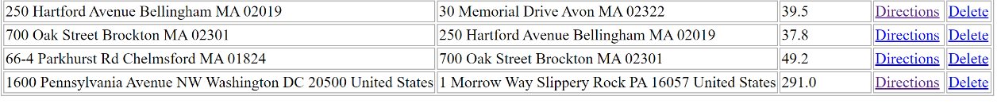

1. If user decides they do not want to continue with a query, they can select “Existing Queries” at the top of the page to return to the home page.

**Finding Distance Between Locations**

1. The distance (in miles) is automatically shown on the home page, to the right of the addresses of each query.

**Finding Directions from Origin to Destination**

1. To the right of the distance entry, user may click on the “Directions” hyperlink to open a new page.

1. This page will have the Instructions for the desired query. When finished, user can select “Existing Queries” button at the top of the page to return to the home page.

**Deleting a Query**

1. Should user desire to delete a query, they may select “Delete” in the far right hyperlink inline with the query to be deleted. This deletion is permanent.

**Data Storage and Persistence**

1. The data for this project is stored locally in a file called data.txt. Which is saved to the programs working directory.

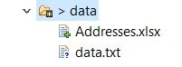

1. The file is not human readable text but is interpreted by the dataController class to load and save google API queries. Thus, reducing unnecessary calls.